PLANT DETAILS
Plant Owner: | Address: |  | Ph:
Plant Make: | Plant Model: | Plant Serial No: | Hours / KM’s:
Rail Reg No: | Reg Expiry: | Project Registration No: | Project Asset No:
Last Service Date / Hrs: | Next service Date / Hrs:
MINIMUM REQUIREMENTS
Verify | Check | Requirement | Verify | Check | Requirement
 |  | Operator and Maintenance Manual available |  |  | Plant Hazard Assessment Sighted & Current (within 2 yrs):
 |  | Logbook / Service Records (checked ok): Maximo |  |  | Plant Hazard Assessment Inspection Date: / /
 |  | Audible Alarm and other Warning Devices fitted, operable and suitable for site conditions |  |  | Daily Prestart Inspection Checklist is available for use.
 |  | Fire Extinguishers Fitted, secure and charged |  |  | Confirm Tamper track gauge and network rail gauge are compatible
 |  | Rail Network Registration Verified for locations to be used on |  |  | Plant Fault Report Book

Instructions: Verify Box to be ticked by Owner / Supplier / Operator prior to arrival onsite. Check Box to be ticked after visual inspection by the project representative
Verify | Check | Cabin
 |  | Check Cleanliness and storage of equipment
 |  | Cabin Doors operational
 |  | Deadman Pedal /switch operational (if fitted)
 |  | Handrails, steps fitted and secure
 |  | Seat – adjustments operational secure
 |  | Seat belt fitted and in good working order
 |  | Check function of UHF Radio
 |  | Check Air conditioning operational
 |  | Check Warning devices/lights/alarms are operational
 |  | Instruments operational & labelled
 |  | Check Cameras/monitors are securely mounted & functional
 |  | Check Levers/controls are labelled & operational
 |  | Foot Pedals in good condition & operational (if fitted)
 |  | Warning Signs & decals fitted -Horn signals/check for OH power
 |  | Travel alarms are appropriate for the environment(check project environmental controls)
 |  | Check window security and free of damage
Verify | Check | Running Controls
 |  | Park brake operational
 |  | Check Service Brake operational
 |  | Check Machine Gauges and controls function correctly
 |  | Check coupling condition, mounting pin and retainer fitted
 |  | Check machine calibration is functional
 |  | Check Throttle control is responsive & functional
 |  | Check function of lifting/lining/level/tamping systems
Verify | Check | Other
 |  | Tamping tyne condition
 |  | Roller clamp condiition
 |  | Work Head auto centre function (if fitted)
Verify | Check | Environmental
 |  | Clean, free of organic materials (mud, dirt, weeds or seeds) prior to arrival
 |  | Engine exhaust, baffling or noise reduction equipment fitted and free of damage or leaks
 |  | Smoke from internal combustion engines should not be visible for more than ten seconds
 |  | No oils leaks evident on hydraulic or drive systems
Verify | Check | Bogies, Wheels & Axles
 |  | Wheels/axles for security
 |  | Bogies frames for security
 |  | Wheels for damage/cracks
Verify | Check | Hydraulics System
 |  | Check hyd Pumps and motors
 |  | Check Hoses / Connectors
 |  | Check Pins / Mountings
 |  | Cylinders (check for excessive wear, leaks and creep)
Verify | Check | Engine
 |  | Engine Mountings
 |  | Engine Guarding
 |  | Exhaust Guarding
 |  | Oil Leaks/levels checked
 |  | Coolant Leaks/levels checked
 |  | Radiator for cleanilness
 |  | Vee Belt Condition & tension
 |  | Air Cleaner System secure
 |  | Check Battery Condition/Security
 |  | Catalytic converter (if fitted)
Verify | Check | Machine Chassis/Body
 |  | Transport to site equipment removed, (lifting lugs)
 |  | Additional Comments

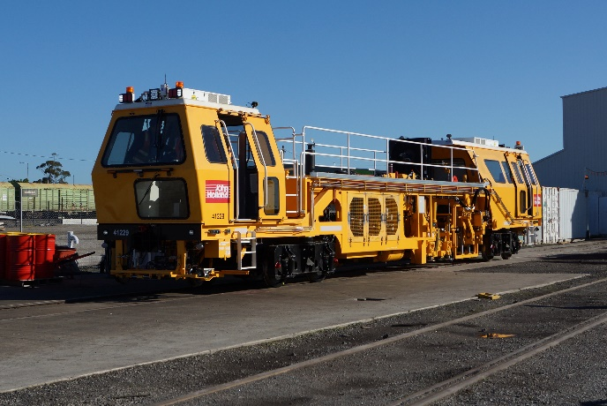
PLANT OWNER/SUPPLIER/OPERATOR | PROJECT REPRESENTATIVE
I certify that the described plant has met the inspection criteria stipulated within this checklist and is being serviced and maintained in accordance with the manufacturer’s specifications | I certify that I have verified that the described plant has met the inspection criteria stipulated within this checklist and is accepted for use on the project.
Name: Signature: Date: | Name: Signature: Date:

