PLANT DETAILS
Plant Owner: | Address: |  | Ph:
Plant Make: | Plant Model: | Plant Serial No: | Hours / KM’s:
Roads Reg No: | Reg Expiry: | Project Registration No: | Project Asset No:
Last Service Date / Hrs: | Next service Date / Hrs:
MINIMUM REQUIREMENTS (If the minimum requirements are not met, a plant sticker will not be issued and the item of plant is not to commence work)
Verify | Check | Requirement | Verify | Check | Requirement
 |  | Operator and Maintenance Manual available |  |  | Plant Hazard Assessment Sighted & Current (within 2 yrs):
 |  | Logbook / Service Records (checked ok): |  |  | Plant Hazard Assessment Inspection Date: / /

Instructions: Verify Box to be ticked by Owner / Supplier / Operator prior to arrival onsite. Check Box to be ticked after visual inspection by the project.
Verify | Check | Sweeper
 |  | Cutting edge free from excessive wear
 |  | Sweeper attachment is sized / rated for the machine size
 |  | Hydraulic hoses and fittings are free from damage.
 |  | No oil Leaks
 |  | Warning devices and other lights (flashing, head, tail, etc) are appropriate for the environment in which plant is being used. (check environment noise criteria particularly if working out of hours)
 |  | Sweeper is free from cracks and damage on Housing
 |  | Condition of the brushes.
 |  | Brushes adjusted to correct height
 |  | Guide wheel (if fitted) / height control
 |  | Approval from manufacturer to use sweeper on machinery
Verify | Check | Hitch
 |  | Maintained and in good working order
 |  | Safety locks available, in good working order
 |  | Hitch matches that of the machine
Verify | Check | Environmental
 |  | Clean, free of organic materials (mud, dirt, weeds or seeds) prior to arrival
 |  | Engine baffling or noise reduction equipment fitted as per manufacturers specifications
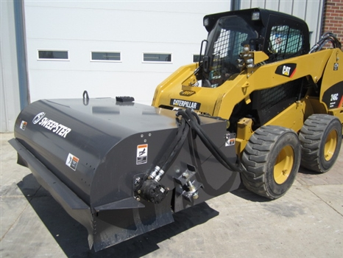
PLANT OWNER / OCCUPIER | PLANT VERIFIER
I certify that the described plant has met the inspection criteria stipulated within this checklist and is being serviced and maintained in accordance with the manufacturer’s specifications | I certify that I have verified that the described plant has met the inspection criteria stipulated within this checklist and is being serviced and maintained in accordance with the manufacturer’s specifications
Name: Signature: Date: | Name: Signature: Date:

