PLANT DETAILS
Plant Owner: | Address: |  | Ph:
Plant Make: | Plant Model: | Plant Serial No: | Hours / KM’s:
Roads Reg No: | Reg Expiry: | Project Registration No: | Project Asset No:
Last Service Date / Hrs: | Next service Date / Hrs:
MINIMUM REQUIREMENTS (If the minimum requirements are not met, a plant sticker will not be issued and the item of plant is not to commence work)

Verify | Check | Requirement | Verify | Check | Requirement
 |  | Operator and Maintenance Manual available |  |  | Plant Hazard Assessment Sighted & Current (within 2 yrs):
 |  | Logbook / Service Records (checked ok): |  |  | Plant Hazard Assessment Inspection Date: / /
 |  | Audible Alarm and other Warning Devices fitted, operable and suitable for site conditions |  |  | Daily Prestart Inspection Checklist is available for use.
 |  | Fire Extinguisher Fitted and charged

Instructions: Verify Box to be ticked by Owner / Supplier / Operator prior to arrival onsite. Check Box to be ticked after visual inspection by the project
Verify | Check | Cabin
 |  | Cleanliness
 |  | Doors operational
 |  | Handrails, steps and ladders fitted and secure
 |  | Seat – adjustments operational secure
 |  | Instruments operational & labelled
 |  | Seat belts fitted
 |  | UHF Radio Fitted (If not fitted, has a hand held radio been supplied)
 |  | Levers / controls operational
 |  | ROPs and FOPs Canopy to meet AS 2294
 |  | Pedals in good condition
 |  | Air conditioning operational (if fitted)
 |  | Warning devices and other lights (flashing, head, tail, etc) are appropriate for the environment in which plant is being used. (check environment noise criteria particularly if working out of hours)
 |  | Warning Signs - DANGER – BEWARE OVERHEAD WIRES & UNDERGROUND SERVICES
 |  | Warning Signs - SEAT BELT MUST BE WORN
 |  | Warning Signs - NOISE WARNING SIGNAGE
 |  | Warning Signs - LASER WORKING AREA
 |  | Air and water systems clean and function
Verify | Check | Running Controls
 |  | Tyres and rims condition
 |  | Tyre inflation
 |  | Brake operational
 |  | Park brake operational
 |  | Stab jack machine levelling function
 |  | Condition and function of cable reeler
Mechanical Checks
Verify | Check | Environmental
 |  | Clean, free of organic materials (mud, dirt, weeds or seeds) prior to arrival
 |  | Engine baffling or noise reduction equipment fitted as per manufacturers specifications
 |  | Smoke from internal combustion engines should not be visible for more than ten seconds
Verify | Check | Booms
 |  | Rock Drill oil filled and functional
 |  | Zoom tube condition and leaks
 |  | Boom mounting bolts to main frame
 |  | Gate, pins and retainer on basket
 |  | Anchor points fitted for fall restraint systems
Verify | Check | Steering
 |  | Articulation maintenance look
 |  | Articulation bearings and retainers
Verify | Check | Hydraulics System
 |  | Rams
 |  | Hoses / connectors
 |  | Pins / mounting
 |  | (check for excessive wear, leaks and creep)
Verify | Check | Engine
 |  | Engine mountings
 |  | Engine guarding
 |  | Exhaust guarding
 |  | Emission test and pass prior to use
 |  | Oil leaks
 |  | Coolant leaks
 |  | Coolant system
 |  | Vee belt condition
 |  | Catalytic converter fitted
 |  | Air cleaner system
 |  | Battery condition / mounting
Verify | Check | Drill Head
 |  | Shank condition
 |  | Hydraulics accumulators
 |  | Feed rail ropes
 |  | Mountings/ feed rails condition
 |  | Drill guidance system fitted (ABC total)
TYRES – Record Tread Depth (if required)
POS 1 (LF) | ____mm | POS 2 (RF) | ____mm
POS 3 (LR) | ____mm | POS 4 (RR) | ____mm

Instructions: Verify Box to be ticked by Owner / Supplier / Operator prior to arrival onsite. Check Box to be ticked after visual inspection by the project
Verify | Check | Cabin
 |  | Rotating beacon operable
 |  | Function of horn
 |  | Dead man switch operational
 |  | Emergency stops where fitted operable
 |  | Machine guidance system fitted and functions
 |  | Reverse alarm operable
 |  | Reversing camera (if fitted)
Verify | Check | Main Panel
 |  | Positive lock out fitted and tested for machine isolation
 |  | Circuit diagrams supplied
 |  | Covers fitted and all door bolts installed
 |  | Door locks functional
 |  | Mechanical interlock of isolation switch
 |  | Shroud for incoming cable, labelled Danger- Alive Isolate Elsewhere
 |  | Panel door, labelled Danger- Alive Isolate Elsewhere
 |  | Danger……… volts sign fitted on front door. (List voltage)
 |  | Panels free from debris and moisture
 |  | Push buttons, isolators and indicators labelled correctly
 |  | Gland plate, door, mounting plate earthed
Electrical Checks
Verify | Check | Meters
 |  | Volt meter
 |  | Amp meter
Verify | Check | Motors electric
 |  | All bolts in covers
 |  | Terminals secure
 |  | Motor mounting bolts secure
Verify | Check | Slip rings/ cable reel
 |  | Clean and free from debris and moisture
 |  | Brushes fitted
 |  | Cable reel limits set
Verify | Check | General
 |  | Check setting of over load and earth leakage as applicable
 |  | Isolation resistance
 |  | Earth continuity
 |  | Check all connections for tightness
 |  | Electrical department to inspect machine prior to power up (safety review)
 |  | Function of head lights
 |  | Function of tail lights
Verify | Check | Trailing Cable
 |  | Overall condition
 |  | Condition of plug
 |  | Cable sock fitted and tied back
 |  | Cable I.D tag fitted
 |  | Test report supplied
 |  | 1000Volt plug of correct amps 300/425 and free from damage with pilot pin fitted
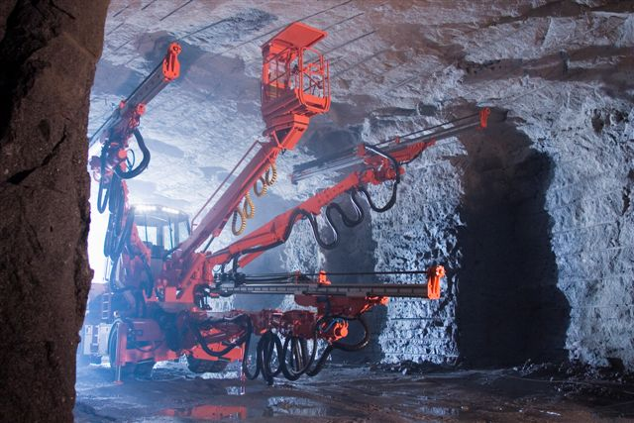
PLANT OWNER / OCCUPIER | PLANT VERIFIER
I certify that the described plant has met the inspection criteria stipulated within this checklist and is being serviced and maintained in accordance with the manufacturer’s specifications | I certify that I have verified that the described plant has met the inspection criteria stipulated within this checklist and is being serviced and maintained in accordance with the manufacturer’s specifications
Name (Mechanical Rep): Signature: Date:  Name (Electrical Rep): Signature: Date: | Name: Signature: Date:

