PLANT DETAILS
Plant Owner: | Address: |  | Ph:
Plant Make: | Plant Model: | Plant Serial No: | Hours / KM’s:
Roads Reg No: | Reg Expiry: | Project Registration No: | Project Asset No:
Last Service Date / Hrs: | Next service Date / Hrs:
MINIMUM REQUIREMENTS (If the minimum requirements are not met, a plant sticker will not be issued and the item of plant is not to commence work)
Verify | Check | Requirement | Verify | Check | Requirement
 |  | Operator and Maintenance Manual available |  |  | Plant Hazard Assessment Sighted & Current (within 2 yrs):
 |  | Logbook / Service Records (checked ok): |  |  | Plant Hazard Assessment Inspection Date: / /

Instructions: Verify Box to be ticked by Owner / Supplier / Operator prior to arrival onsite. Check Box to be ticked after visual inspection by the project.
Verify | Check | Jib
 |  | SWL marked on JIB
 |  | Jib attachment is sized / rated for the machine size
 |  | Certified for lifting
 |  | Lugs are crack and damage free
 |  | Jib is free from cracks and damage
 |  | Swivel hook free from damage and latch is functioning correctly
 |  | Hook and shackle tagged and inspected in last 3 months
 |  | Shackle mount hole / lug less than 10% wear and free from damage.
 |  | Jib slide position pin and retainer fitted and functional
 |  | Load chart available in machines of intended use for different jib positions.
 |  | Approval from manufacturer to use Jib on machinery
Verify | Check | Hitch
 |  | Maintained and in good working order
 |  | Quick hitch safety pins and locks available and in good working order
 |  | Hitch matches that of the machine(s) of intended use
Verify | Check | Environmental
 |  | Clean, free of organic materials (mud, dirt, weeds or seeds) prior to arrival
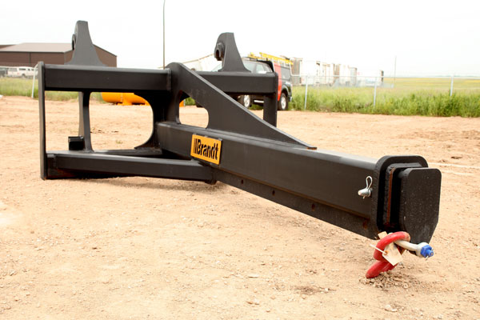
PLANT OWNER / OCCUPIER | PLANT VERIFIER
I certify that the described plant has met the inspection criteria stipulated within this checklist and is being serviced and maintained in accordance with the manufacturer’s specifications | I certify that I have verified that the described plant has met the inspection criteria stipulated within this checklist and is being serviced and maintained in accordance with the manufacturer’s specifications
Name: Signature: Date: | Name: Signature: Date:

