PLANT DETAILS
Plant Owner: | Address: |  | Ph:
Plant Make: | Plant Model: | Plant Serial No: | Hours / KM’s:
Roads Reg No: | Reg Expiry: | Project Registration No: | Project Asset No:
Last Service Date / Hrs: | Next service Date / Hrs:
MINIMUM REQUIREMENTS (If the minimum requirements are not met, a plant sticker will not be issued and the item of plant is not to commence work)
Verify | Check | Requirement | Verify | Check | Requirement
 |  | Operator and Maintenance Manual available |  |  | Plant Hazard Assessment Sighted & Current (within 2 yrs):
 |  | Logbook / Service Records (checked ok): |  |  | Plant Hazard Assessment Inspection Date: / /
 |  | Audible Alarm and other Warning Devices fitted, operable and suitable for site conditions |  |  | Daily Prestart Inspection Checklist is available for use.
 |  | Fire Extinguisher Fitted and charged

Instructions: Verify Box to be ticked by Owner / Supplier / Operator prior to arrival onsite. Check Box to be ticked after visual inspection by the project Mechanical fitter.
Verify | Check | Cabin
 |  | Cleanliness
 |  | Door/ rail bar operational
 |  | Remote control operation and cable condition
 |  | Instruments operational & labelled
 |  | Seat – adjustments operational secure
 |  | Seat belt fitted and in good working order
 |  | Levers / Controls Operational
 |  | Pedals in good condition
 |  | ROPs Canopy to meet AS 2294
 |  | Warning devices and other lights (flashing, head, tail, etc) are appropriate for the environment in which plant is being used. (check environment noise criteria particularly if working out of hours)
 |  | Warning Signs – DANGER – BEWARE OVERHEAD WIRES
Verify | Check | Pump Components
 |  | Turret
 |  | Support Frame
 |  | Pump/ control gauges fitted and are legible
 |  | Delivery line, hoses & connections (check for excessive, wear, leaks and damage)
 |  | Boom pedestal
 |  | Slew Ring
 |  | Transport safe guard, boom stop
 |  | Delivery line, pipes, connections , thickness test on steel pipe
 |  | Accelerator pump/line is clear
 |  | Accelerator dosing pump working and recording flow
 |  | Concrete hopper is clean
 |  | No excessive gap between hopper wear plate and swing tube
 |  | Hopper vibrator works correctly
 |  | Hopper grate safety valve cut out pump when gate lifted
Mechanical Checks
Verify | Check | Environmental
 |  | Clean, free of organic materials (mud, dirt, weeds or seeds) prior to arrival
 |  | Engine baffling or noise reduction equipment fitted as per manufacturers specifications
 |  | Smoke from internal combustion engines should not be visible for more than ten seconds
 |  | Emissions test complete and passed
Verify | Check | Hydraulics
 |  | Rams
 |  | Hoses
 |  | Connections (check for excessive wear, leaks and creep)
 |  | Front stabilizers
 |  | Rear stabilizers
 |  | Boom 1 cylinder & safety values
 |  | Boom 2 cylinder & safety values
 |  | The lance wear strips and chain condition/tension is correct
 |  | Oscillation head function and mounting
 |  | Nozzle head rotation plate, motor and mounting in good condition/ function
 |  | Lance extend/ retract cylinder condition and connection pin/retainers
Verify | Check | Engine
 |  | Engine mountings
 |  | Engine guarding
 |  | Exhaust guarding
 |  | Oil leaks/levels checked
 |  | Coolant leaks/levels checked
 |  | Coolant system
 |  | Vee belt condition
 |  | Air Cleaner System
 |  | Battery condition / mounting
 |  | Catalytic converter fitted
Verify | Check | Running Gear
 |  | Tyres / wheels undamaged
 |  | Brakes are operational
 |  | Park brake is operational
TYRES – Record Tread Depth (if required)
POS 1 (LF) | ____mm | POS 2 (RF) | ____mm
POS 3 (LR) | ____mm | POS 4 (RR) | ____mm
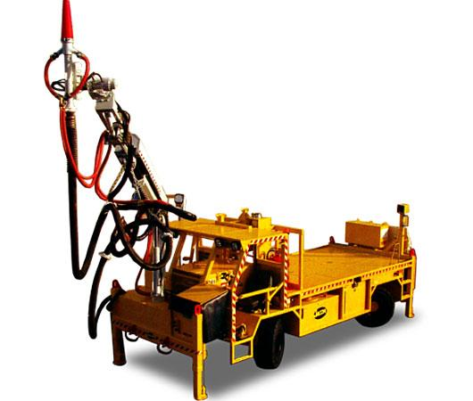

Instructions: Verify Box to be ticked by Owner / Supplier / Operator prior to arrival onsite. Check Box to be ticked after visual inspection by the project Electrician.
Verify | Check | Main Panel
 |  | Positive lock out fitted and tested for machine isolation
 |  | Circuit diagrams supplied
 |  | Covers fitted and all door bolts installed
 |  | Door locks functional
 |  | Mechanical interlock of isolation switch
 |  | Shroud for incoming cable, labelled Danger- Alive Isolate Elsewhere
 |  | Panel door, labelled Danger- Alive Isolate Elsewhere
 |  | Danger ______ volts sign fitted on front door (fill in required voltage)
 |  | Sticker Isolate elsewhere before oping panel
 |  | Panels free from debris and moisture
 |  | Push buttons, isolators and indicators labelled correctly
 |  | Gland plate, door, mounting plate earthed
Verify | Check | Trailing Cable
 |  | Overall condition
 |  | Condition of plug
 |  | Cable sock fitted and tied back
 |  | Cable I.D tag fitted
 |  | Test report supplied
 |  | 1000Volt plug of correct amps 300/425 and free from damage with pilot pin fitted
 |  | Cable reel condition and function
Verify | Check | Slip rings/ cable reel
 |  | Clean and free from debris and moisture
 |  | Brushes fitted
 |  | Cable reel limits set
Verify | Check | General
 |  | Check setting of over load and earth leakage as applicable
 |  | Isolation resistance
 |  | Earth continuity
 |  | Check all connections for tightness
 |  | Electrical department to inspect machine prior to power up (internal electrical compliance safety review)
 |  | Function of head lights and boom lights. Check they are free from water on the inside
 |  | Function of tail lights
Verify | Check | Motors electric
 |  | All bolts in covers
 |  | Terminals secure
 |  | Motor mounting bolts secure
Electrical Checks
Verify | Check | Meters
 |  | Volt meter
 |  | Amp meter
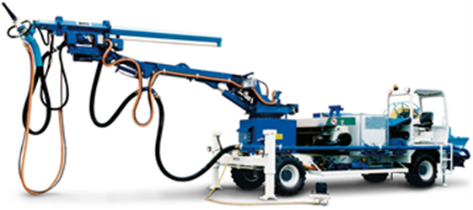
PLANT OWNER / OCCUPIER | PLANT VERIFIER
I certify that the described plant has met the inspection criteria stipulated within this checklist and is being serviced and maintained in accordance with the manufacturer’s specifications | I certify that I have verified that the described plant has met the inspection criteria stipulated within this checklist and is being serviced and maintained in accordance with the manufacturer’s specifications
Name (electrical Rep): Signature: Date:  Name (Mechanical Rep): Signature: Date: | Name: Signature: Date:

