PLANT DETAILS
Plant Owner: | Address: |  | Ph:
Plant Make: | Plant Model: | Plant Serial No: | Hours / KM’s:
Roads Reg No: | Reg Expiry: | Project Registration No: | Project Asset No:
Last Service Date / Hrs: | Next service Date / Hrs:
MINIMUM REQUIREMENTS (If the minimum requirements are not met, a plant sticker will not be issued and the item of plant is not to commence work)
Verify | Check | Requirement | Verify | Check | Requirement
 |  | Operator and Maintenance Manual available |  |  | Plant Hazard Assessment Sighted & Current (within 2 yrs):
 |  | Logbook / Service Records (checked ok): |  |  | Plant Hazard Assessment Inspection Date: / /
 |  | Audible Alarm and other Warning Devices fitted, operable and suitable for site conditions |  |  | Daily Prestart Inspection Checklist is available for use.

Instructions: Verify Box to be ticked by Owner / Supplier / Operator prior to arrival onsite. Check Box to be ticked after visual inspection by the project
Verify | Check | Body
 |  | Cleanliness
 |  | Doors operational
 |  | Emergency Stop
 |  | Light Switches are safe
 |  | Instruments operational & labelled
 |  | Levers / Controls Operational
 |  | Warning devices and other lights (flashing, head, tail, etc) are appropriate for the environment in which plant is being used. (check environment noise criteria particularly if working out of hours)
 |  | Fire extinguisher/s fitted and charged
 |  | Lockable battery isolation switch
Verify | Check | Draw Bar
 |  | Hitch Secure
 |  | Security chains in good condition for tow hitch
 |  | Frame no weld cracks
 |  | Retractable draw bar works properly
Verify | Check | Running Gear
 |  | Tyres / Wheels undamaged
 |  | Springs
 |  | Park brake is operational
 |  | Jockey Wheel operational and lockable
 |  | Stabilizers operational
Verify | Check | Environmental
 |  | Clean, free of organic materials (mud, dirt, weeds or seeds) prior to arrival
 |  | Engine baffling or noise reduction equipment fitted as per manufacturers specifications
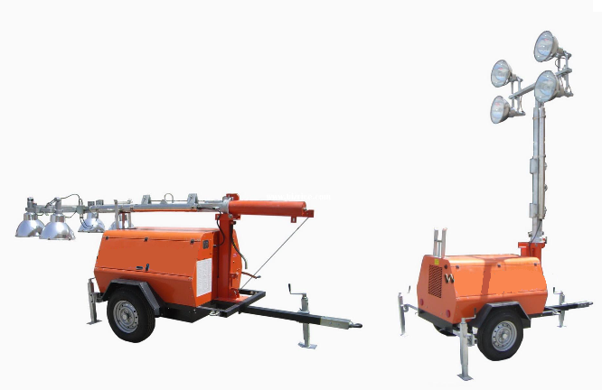 |  | Smoke from internal combustion engines should not be visible for more than ten seconds
Verify | Check | Outriggers
 |  | All in place
 |  | Good working condition
 |  | Locking Latches working
Verify | Check | Light Mast
 |  | Hydraulics Rams working
 |  | Hydraulics Hoses / Connectors
 |  | Winches and Wire working
 |  | Pins / Mounting good condition
 |  | Light bulb covers in place
 |  | Warning decal – erected allowable max wind speed eg Max 118 km
Verify | Check | Engine
 |  | Engine Mountings
 |  | Engine Guarding
 |  | Exhaust Guarding
 |  | Oil Leaks
 |  | Coolant Leaks
 |  | Fuel Leaks
 |  | Coolant System
 |  | Vee Belt Condition
 |  | Air Cleaner System
 |  | Battery Condition / Mounting
TYRES – Record Tread Depth (if required)
POS 1 (LF) | ____mm | POS 2 (RF) | ____mm

PLANT OWNER / OCCUPIER | PLANT VERIFIER
I certify that the described plant has met the inspection criteria stipulated within this checklist and is being serviced and maintained in accordance with the manufacturer’s specifications | I certify that I have verified that the described plant has met the inspection criteria stipulated within this checklist and is being serviced and maintained in accordance with the manufacturer’s specifications
Name: Signature: Date: | Name: Signature: Date:

