PLANT DETAILS
Plant Owner: | Address: |  | Ph:
Plant Make: | Plant Model: | Vin No | Hours / KM’s:
Roads Reg No: | Reg Expiry: | Project Registration No: | Project Asset No:
Last Service Date / Hrs: | Next service Date / Hrs:
Driver’s Name: | Licence Number: | Licence Expiry Date: | 2WD 4WD
Fuel: Petrol Diesel Gas | Gas Tank date: | 2 Door 4 Door | Sedan Hatch Wagon Ute Tray
MINIMUM REQUIREMENTS (If the minimum requirements are not met, a plant sticker will not be issued and the item of plant is not to commence work)
Verify | Check | Requirement | Verify | Check | Requirement
 |  | Operator and Maintenance Manual available |  |  | Plant Hazard Assessment Sighted & Current (within 2 yrs):
 |  | Logbook / Service Records (checked ok): |  |  | Plant Hazard Assessment Inspection Date: / /
 |  | Audible Alarm and other Warning Devices fitted, operable and suitable for site conditions |  |  | Daily Prestart Inspection Checklist is available for use.
 |  | Fire Extinguisher Fitted and charged
 |  | Vehicle must also be equipped with ABS breaks, driver and passenger airbags and Bluetooth capability

Instructions: Verify Box to be ticked by Owner / Supplier / Operator prior to arrival onsite. Check Box to be ticked after visual inspection by the project
Verify | Check | Cabin
 |  | Cleanliness
 |  | Door operational
 |  | Seat adjustments operational secure
 |  | Seat belt fitted and in good working order
 |  | UHF Radio Fitted (If not fitted, has a hand held radio been supplied)
 |  | First Aid Kit available
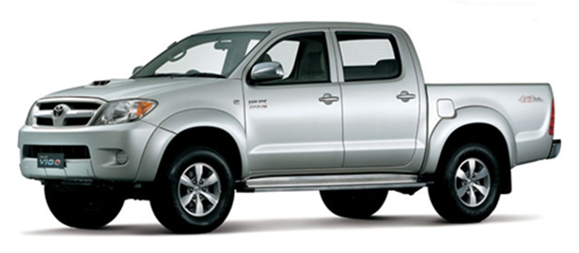
Levers / Controls Operational
 |  | Instruments operational
 |  | Spare wheel
 |  | Warning devices and other lights (flashing, head, tail, etc) are appropriate for the environment in which plant is being used. (check environment noise criteria particularly if working out of hours)
 |  | Pedals in good condition
 |  | Air conditioning operational
 |  | Wipers / Washers operational
 |  | Rear View Mirrors
 |  | Windows not damaged
Verify | Check | Running Gear
 |  | Tyres / Wheels undamaged/ Inflated
 |  | Brakes operational
 |  | Park brake working
Verify | Check | Environmental
 |  | Clean, free of organic materials (mud, dirt, weeds or seeds) prior to arrival
 |  | Engine baffling or noise reduction equipment fitted as per manufacturers specifications
 |  | Smoke from internal combustion engines should not be visible for more than ten seconds
Verify | Check | Warning Devices
 |  | Horn
 |  | Amber flashing light
 |  | Headlights & turn indicators
 |  | Reverse alarm operable
Verify | Check | Engine
 |  | Engine Mountings
 |  | Engine Guarding
 |  | Exhaust Guarding
 |  | Oil Leaks/check levels
 |  | Coolant Leaks
 |  | Coolant System
 |  | Vee Belt Condition
 |  | Air Cleaner System
 |  | Battery Condition / Mounting
Note any visible body damage:
TYRES – Record Tread Depth (if required)
POS 1 (LF) | ____mm | POS 2 (RF) | ____mm
POS 3 (LR) | ____mm | POS 4 (RR) | ____mm

PLANT OWNER / OCCUPIER | PLANT VERIFIER
I certify that the described plant has met the inspection criteria stipulated within this checklist and is being serviced and maintained in accordance with the manufacturer’s specifications | I certify that I have verified that the described plant has met the inspection criteria stipulated within this checklist and is being serviced and maintained in accordance with the manufacturer’s specifications
Name: Signature: Date: | Name: Signature: Date:

