PLANT DETAILS
Plant Owner: | Address: |  | Ph:
Plant Make: | Plant Model: | Plant Serial No: | Hours / KM’s:
Roads Reg No: | Reg Expiry: | Project Registration No: | Project Asset No:
Last Service Date / Hrs: | Next service Date / Hrs: | CraneSafe Permit No: | CraneSafe expiry date:
State (eg: WorkCover) Plant Registration No
MINIMUM REQUIREMENTS (If the minimum requirements are not met, a plant sticker will not be issued and the item of plant is not to commence work)
Is this crane fitted with a free fall function if your answer is “Yes” the crane cannot be used unless an effective lockout system is installed and tested (while the lock is installed) to verify that free fall cannot be inadvertently activated.
This test must be conducted by a competent operator as part of the Pre-Acceptance Inspection process and detailed within the Plant Hazard Assessment.

Verify | Check | Requirement | Verify | Check | Requirement
 |  | Operator and Maintenance Manual available |  |  | Plant Hazard Assessment Sighted & Current (within 2 yrs):
 |  | Logbook / Service Records (checked ok): |  |  | Plant Hazard Assessment Inspection Date: / /
 |  | Audible Alarm and other Warning Devices fitted, operable and suitable for site conditions |  |  | Daily Prestart Inspection Checklist is available for use.
 |  | Fire Extinguisher Fitted and charged |  |  | Operation instruction for machine setup on outriggers present

Instructions: Verify Box to be ticked by Owner / Supplier / Operator prior to arrival onsite. Check Box to be ticked after visual inspection by the project
Verify | Check | Cabin
 |  | Cleanliness
 |  | Door operational
 |  | Deadman Pedal /Switch operational
 |  | Handrails and ladders fitted and secure
 |  | Seat – adjustments operational secure
 |  | Seat belt fitted and in good working order
 |  | UHF Radio Fitted (If not fitted, has a hand held radio been supplied)
 |  | First Aid Kit, triangle and road reflectors available
 |  | Warning devices and other lights (flashing, head, tail, etc) are appropriate for the environment in which plant is being used. (check environment noise criteria particularly if working out of hours)
 |  | Instruments operational & labelled
 |  | Levers / Controls Operational
 |  | Pedals in good condition
 |  | Air conditioning operational
 |  | Wipers / Washers operational
 |  | Rear View Mirrors
 |  | Windows not damaged
 |  | Warning Signs - Seat belt must be worn
 |  | Warning Signs - Danger – Beware Overhead Wires
Verify | Check | Running Gear
 |  | Tyres / Wheels undamaged
 |  | Brakes system operational
 |  | Park brake is operational
Verify | Check | Environmental
 |  | Clean, free of organic materials (mud, dirt, weeds or seeds) prior to arrival
 |  | Engine baffling or noise reduction equipment fitted as per manufacturers specifications
 |  | Smoke from internal combustion engines should not be visible for more than ten seconds
Verify | Check | Lifting Equipment Accessories
 |  | Slings / ropes /chains / shackles (tagged and labelled in good working condition)
 |  | Steel or timber pads
 |  | Chains tagged in the last 12 months
 |  | 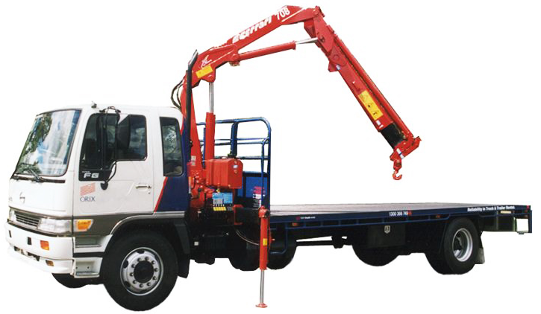Soft slings tagged in the last 3 months
 |  | SWL Crane charts
Verify | Check | Crane assembly
 |  | Crane mounts secure
 |  | Crane Boom integrity
 |  | Crane Instruction signage
 |  | Crane Controls
 |  | Crane Hooks
 |  | Rams
 |  | Pins / Mountings
 |  | Hoses / Connectors
 |  | (check for excessive wear, leaks and creep)
 |  | Access points hand rails and steps fitted and secured
 |  | Outriggers functional
 |  | Outrigger locking pins/mechanisms functioning effectively
Verify | Check | Engine
 |  | Engine Mountings
 |  | Engine Guarding
 |  | Exhaust Guarding
 |  | Oil Leaks/check levels
 |  | Coolant Leaks/check levels
 |  | Coolant System
 |  | Vee Belt Condition
 |  | Air Cleaner System
 |  | Battery Condition / Mounting
TYRES – Record Tread Depth (if required)
POS 1 (LF) | ____mm | POS 2 (RF) | ____mm
POS 3 (LF2) | ____mm | POS 4 (RF2) | ____mm
POS 5 (LR3) | ____mm | POS 6 (RR3) | ____mm

PLANT OWNER / OCCUPIER | PLANT VERIFIER
I certify that the described plant has met the inspection criteria stipulated within this checklist and is being serviced and maintained in accordance with the manufacturer’s specifications | I certify that I have verified that the described plant has met the inspection criteria stipulated within this checklist and is being serviced and maintained in accordance with the manufacturer’s specifications
Name: Signature: Date: | Name: Signature: Date:

