PLANT DETAILS
Plant Owner: | Address: |  | Ph:
Plant Make: | Plant Model: | Plant Serial No: | Hours / KM’s:
Roads Reg No: | Reg Expiry: | Project Registration No: | Project Asset No:
Last Service Date / Hrs: | Next service Date / Hrs:
MINIMUM REQUIREMENTS (If the minimum requirements are not met, a plant sticker will not be issued and the item of plant is not to commence work)

Verify | Check | Requirement | Verify | Check | Requirement
 |  | Operator and Maintenance Manual available |  |  | Plant Hazard Assessment Sighted & Current (within 2 yrs):
 |  | Logbook / Service Records (checked ok): |  |  | Plant Hazard Assessment Inspection Date: / /

Verify | Check | Basket
 |  | Cleanliness
 |  | Self-Closing gate operational
 |  | Deadman Pedal /Switch operational
 |  | Handrails fitted and secured
 |  | Anchor points are in place and not damaged
 |  | Safety harness and lanyard available
 |  | Labelling in place
 |  | Emergency stops where fitted operable (eg. Deadman switches)
 |  | Horn and alarms operable (raise /lower, out of level, motion alarms)
 |  | Warning devices and other lights (flashing, head, tail, etc) are appropriate for the environment in which plant is being used. (check environment noise criteria particularly if working out of hours)
 |  | Is the protective guarding of joystick controls adequate
 |  | Sliding deck functioning
Verify | Check | Hydraulics
 |  | Rams
 |  | Hoses
 |  | Connections
 |  | (check for excessive wear, leaks and creep)
Verify | Check | Running Gear
 |  | Tyres / Wheels / Tracks undamaged
 |  | Park brake is operational
 |  | Access ladder undamaged
 |  | Levelling jacks functional
Verify | Check | Environmental
 |  | Clean, free of organic materials (mud, dirt, weeds or seeds) prior to arrival
 |  | Engine baffling or noise reduction equipment fitted as per manufacturers specifications
 |  | Smoke from internal combustion engines should not be visible for more than ten seconds
Verify | Check | Lifting Mechanism
 |  | Pivots
 |  | Connecting Rods
 |  | Safety Pins (No excessive wear)
Verify | Check | Operation
 |  | Operating controls operational
 |  | Ground-level operating controls operational
 |  | Levers / controls guarded against in advertent operation
 |  | Deadman Switch operational
 |  | Flashing beacon operating and Motion alarm audible
 |  | Removable platform controls if manoeuvring through doorways
Verify | Check | Engine
 |  | Engine Guarding
 |  | Exhaust (if applicable)
 |  | Fluid levels
Verify | Check | Warning Signs
 |  | Warning Signs - Danger – Beware Overhead Wires
 |  | Limits of internal & external use
 |  | Wind Speed Capability
 |  | Safe Working Load
Instructions: Verify Box to be ticked by Owner / Supplier / Operator prior to arrival onsite. Check Box to be ticked after visual inspection by the project
Levers /Controls guarded against in advertent operation
TYRES – Record Tread Depth (if required)
POS 1 (LF) | ____mm | POS 2 (RF) | ____mm
POS 3 (LR) | ____mm | POS 4 (RR) | ____mm
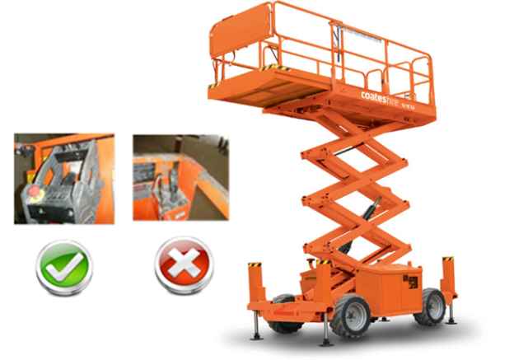

PLANT OWNER / OCCUPIER | PLANT VERIFIER
I certify that the described plant has met the inspection criteria stipulated within this checklist and is being serviced and maintained in accordance with the manufacturer’s specifications | I certify that I have verified that the described plant has met the inspection criteria stipulated within this checklist and is being serviced and maintained in accordance with the manufacturer’s specifications
Name: Signature: Date: | Name: Signature: Date:

