PLANT DETAILS
Plant Owner: | Address: |  | Ph:
Plant Make: | Plant Model: | Plant Serial No: | Hours / KM’s:
Roads Reg No: | Reg Expiry: | Project Registration No: | Project Asset No:
Last Service Date / Hrs: | Next service Date / Hrs:
MINIMUM REQUIREMENTS (If the minimum requirements are not met, a plant sticker will not be issued and the item of plant is not to commence work)

Verify | Check | Requirement | Verify | Check | Requirement
 |  | Operator and Maintenance Manual available |  |  | Plant Hazard Assessment Sighted & Current (within 2 yrs):
 |  | Logbook / Service Records (checked ok): |  |  | Plant Hazard Assessment Inspection Date: / /

Verify | Check | Operator’s Station
 |  | Cleanliness
 |  | Emergency Stop buttons operational
 |  | Handrails and ladders fitted and secure with fall barrier gates
 |  | Seat – adjustments operational secure
 |  | Seat belt fitted and in good working order
 |  | Warning devices and other lights (flashing, head, tail, etc) are appropriate for the environment in which plant is being used. (check environment noise criteria particularly if working out of hours)
 |  | Instruments operational & labelled
 |  | UHF Radio Fitted (If not fitted, has a hand held radio been supplied)
 |  | Drive Lever / Controls Operational
 |  | Overhead canopy secure
 |  | Warning Signs - Seat belt must be worn, keep clear from conveyor belt and crush zone areas identified.
 |  | Audible Alarms operational
Verify | Check | Front Hooper
 |  | No visible damage
 |  | Liner plates secure
 |  | Vibrator operational
 |  | Conveyor System attachments secure
 |  | Guarding secure and in place
 |  | Adjustable push rollers are free from fouling
 |  | Auger
 |  | Conveyor secure
 |  | Conveyor on/off controls operational
Verify | Check | Environmental
 |  | Clean, free of organic materials (mud, dirt, weeds or seeds) prior to arrival
 |  | Engine baffling or noise reduction equipment fitted as per manufacturers specifications
 |  | Smoke from internal combustion engines should not be visible for more than ten seconds
Verify | Check | Steering
 |  | Unions
 |  | Pivots
 |  | Connecting Rods
 |  | Steering Linkages / Rams
Verify | Check | Hydraulics Systems
 |  | Rams
 |  | Hoses / Connectors
 |  | Pins / Mounting
(check for excessive
wear, leaks and creep)
Verify | Check | Engine
 |  | Engines Mountings
 |  | Engines Guarding
 |  | Exhaust Guarding
 |  | Oil Leaks/check levels
 |  | Coolant Leaks/check levels
 |  | Coolant System
 |  | Vee Belt Condition
 |  | Air Cleaner System
 |  | Battery Condition / Mounting
Verify | Check | Fume Extraction System
 |  | Fan operational
 |  | Exhaust pipes are operational
Verify | Check | Running Controls
 |  | Wheels are undamaged
 |  | Brake operational
 |  | Park brake is operational
Instructions: Verify Box to be ticked by Owner / Supplier / Operator prior to arrival onsite. Check Box to be ticked after visual inspection by the project
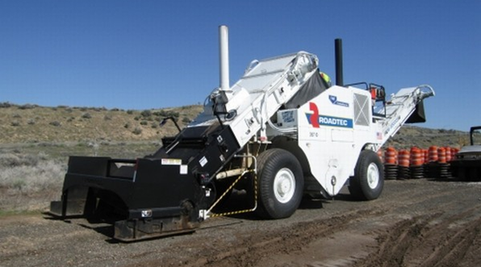

TYRES – Record Tread Depth (if required)
POS 1 (LF) | ____mm | POS 2 (RF) | ____mm
POS 3 (LM) | ____mm | POS 4 (RM) | ____mm

PLANT OWNER / OCCUPIER | PLANT VERIFIER
I certify that the described plant has met the inspection criteria stipulated within this checklist and is being serviced and maintained in accordance with the manufacturer’s specifications | I certify that I have verified that the described plant has met the inspection criteria stipulated within this checklist and is being serviced and maintained in accordance with the manufacturer’s specifications
Name: Signature: Date: | Name: Signature: Date:

