PLANT DETAILS
Plant Owner: | Address: |  | Ph:
Plant Make: | Plant Model: | Plant Serial No: | Hours / KM’s:
Roads Reg No: | Reg Expiry: | Project Registration No: | Project Asset No:
Last Service Date / Hrs: | Next service Date / Hrs:
MINIMUM REQUIREMENTS (If the minimum requirements are not met, a plant sticker will not be issued and the item of plant is not to commence work)
Verify | Check | Requirement | Verify | Check | Requirement
 |  | Operator and Maintenance Manual available |  |  | Plant Hazard Assessment Sighted & Current (within 2 yrs):
 |  | Logbook / Service Records (checked ok): |  |  | Plant Hazard Assessment Inspection Date: / /
 |  | Audible Alarm and other Warning Devices fitted, operable and suitable for site conditions |  |  | Daily Prestart Inspection Checklist is available for use.
 |  | Fire Extinguisher Fitted and charged

Instructions: Verify Box to be ticked by Owner / Supplier / Operator prior to arrival onsite. Check Box to be ticked after visual inspection by the project
Verify | Check | Cabin
 |  | Cleanliness
 |  | Door operational
 |  | Deadman Pedal /Switch operational
 |  | Handrails and ladders fitted and secure
 |  | Seat – adjustments operational secure
 |  | Instruments operational & labeled
 |  | Seat belt fitted and in good working order
 |  | Levers / Controls Operational
 |  | Pedals in good condition
 |  | Air conditioning operational
 |  | Wipers / Washers operational
 |  | Rear View Mirrors
 |  | ROPs and FOPs Canopy to meet AS 2294
 |  | Windows not damaged
 |  | SWL / Crane Chart
 |  | Warning devices and other lights (flashing, head, tail, etc) are appropriate for the environment in which plant is being used. (check environment noise criteria particularly if working out of hours)
 |  | Warning Signs - Seat belt must be worn
 |  | Warning Signs - Dial Before You Dig
 |  | Warning Signs - Danger – Beware Overhead Wires & Underground Services
Verify | Check | Hydraulics
 |  | Rams
 |  | Hoses
 |  | Connections (check for excessive wear, leaks and creep)
Verify | Check | Environmental
 |  | Clean, free of organic materials (mud, dirt, weeds or seeds) prior to arrival
 |  | Engine baffling or noise reduction equipment fitted as per manufacturers specifications
 |  | Smoke from internal combustion engines should not be visible for more than ten seconds
Verify | Check | Undercarriage
 |  | Tracks complete and undamaged
 |  | Idlers / Rollers
 |  | Drivers free from leaks
 |  | Tracks drive Sprockets.
 |  | Articulation (slew) bearings and retainers
 |  | Track Tension
Verify | Check | Engine
 |  | Engine Guarding
 |  | Exhaust Guarding
 |  | Fluid levels
 |  | Water Leaks/ levels checked
 |  | Radiator Hose & Clamps
 |  | Radiator Core Condition
 |  | Vee Belt Condition
 |  | Fan Hub Bearings
 |  | Oil Leaks /levels checked
 |  | Air Intake Hoses & Clamps
 |  | Air Cleaner
 |  | Mountings
 |  | Battery Condition
Verify | Check | Attachments
 |  | Quick hitch
 |  | Safety pins (as applicable)
 |  | SWL Safe Working Load decal attached to arm
 |  | Crane valves / Hose Burst Protection if used for Lifting or Maximum 1000KG SWL located on loader frame or Jib
 |  | If quick hitch is fitted NO LIFTING POINTS ALLOWED on back of bucket
 |  | Correct size attachments supplied
 |  | Mesh screens in place (applies when rock breaker attachment fitted)
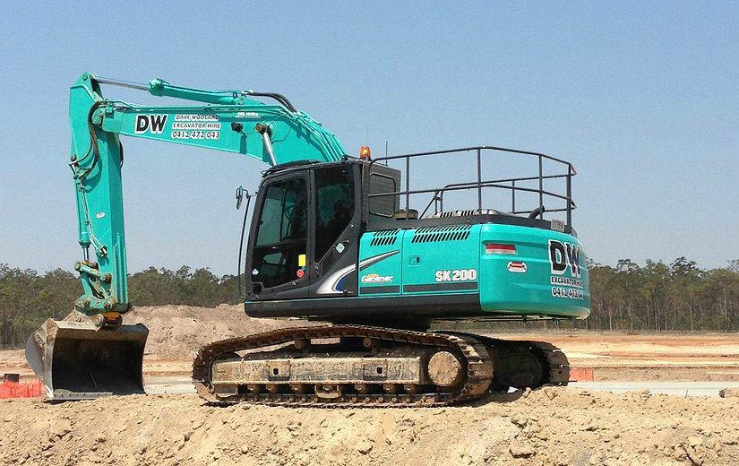
PLANT OWNER / OCCUPIER | PLANT VERIFIER
I certify that the described plant has met the inspection criteria stipulated within this checklist and is being serviced and maintained in accordance with the manufacturer’s specifications | I certify that I have verified that the described plant has met the inspection criteria stipulated within this checklist and is being serviced and maintained in accordance with the manufacturer’s specifications
Name: Signature: Date: | Name: Signature: Date:

